**Visualisation Project** 

“COVID-19 Impacts in different aspects”

Student Name: Anqi Hu

Student ID: 30342295

Tutor Name: Aldrich Clarence, Kadek Satriadi

# **Introduction**

The world experienced a disaster in 2020, with the emergence of COVID-19 affecting

the entire globe to varying degrees. Nearly 150 countries closed all schools and forced

the cancellation of activities during the outbreak, and more than 80 countries closed

all workplaces in an effort to contain the spread of the virus.

Travel restrictions are common. The enforced blockade, coupled with a conscious social distance between consumers and producers, has disrupted global economic activity and trade, along with volatility in financial markets and plummeting prices for crude oil and industrial metals.

This visual analysis is mainly to explore the changes in the economic index and human development index under the influence of the epidemic. At the same time, it is also hoped that through the analysis of the data, we can observe the changes in the economic conditions of different countries under the pressure of the epidemic.

Finally, by exploring the changes in the unemployment rate in recent years, people's living conditions in the economic depression caused by the epidemic are obtained.

Design

In the initial design stage, a dashboard is prepared to lay out all the visualization charts. In the dashboard, for different topics, it is divided into three interfaces that can be switched, so that users can focus on the in-depth exploration data in a topic.

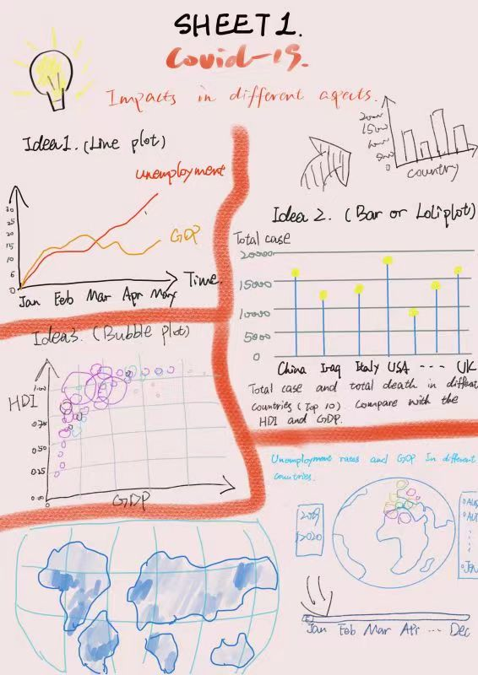

For the epidemic change data, economic data, and unemployment rate data, the visual display is carried out in the form of histogram, line chart, scatter bubble chart, and map. In terms of interaction, the drop-down box contains multiple selections and single selections to filter data, and a time axis to display dynamic data that changes over time.

# **Implementation**

Tool used is R with shiny package, data is cleaned two csv file, plot is generate by ggplot and ggplotly, map is build by leaflet. The entire page layout is based on shiny dashboard theme. The Geo-data is load from package spData to generate the shape of each country.

Library used:

library(shiny)

library(shinydashboard)

library(plotly)

library(lubridate)

library(dplyr)

library(tidyverse)

library(RColorBrewer)

library(ggplot2)

library(leaflet)

library(rworldmap)

library(dplyr)

library(tidyverse)

library(inspectdf)

library(hrbrthemes)

library(viridisLite)

library(viridis)

library(spData)

library(sf)

library(mapdata)

library(leaflet)

library(countrycode)

# **User Guide**

Open the project and open the app.R, then click Run app to start the project

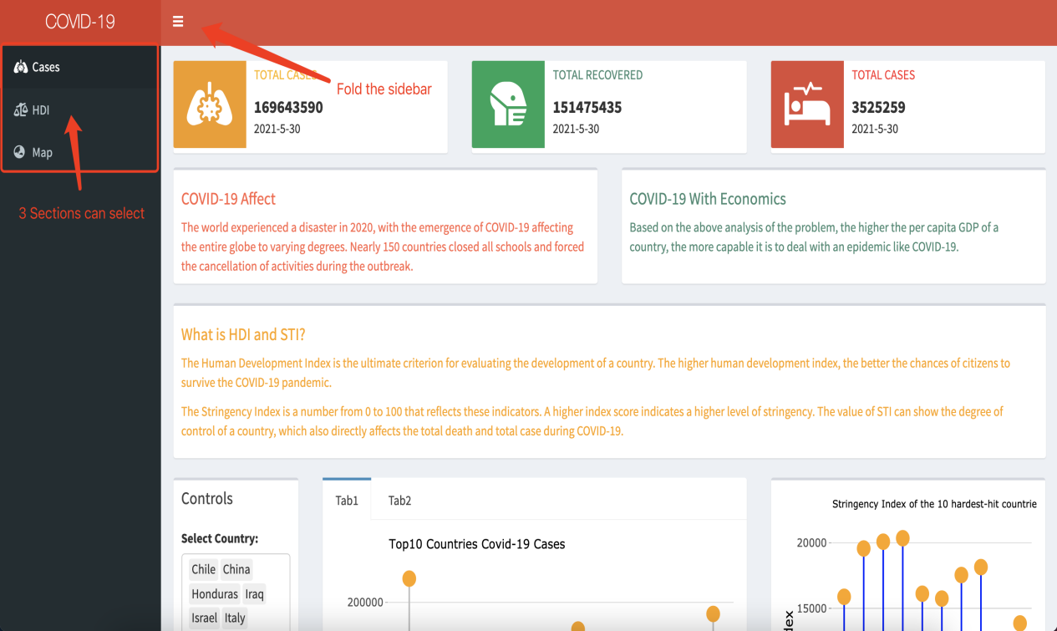

The main page is a dashboard layout, and contains three sections

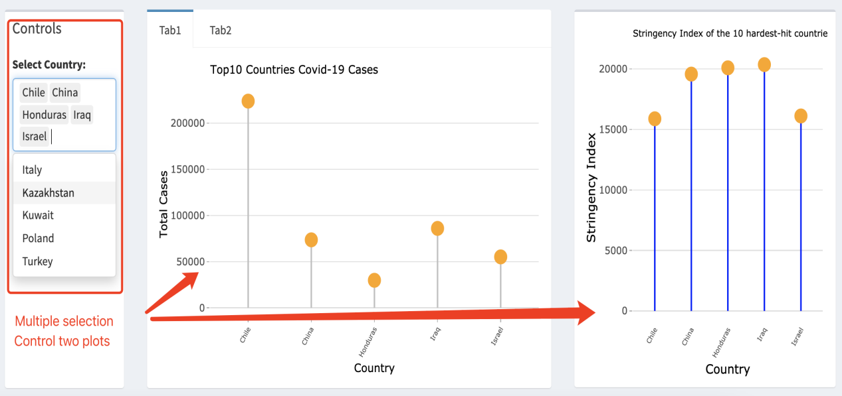

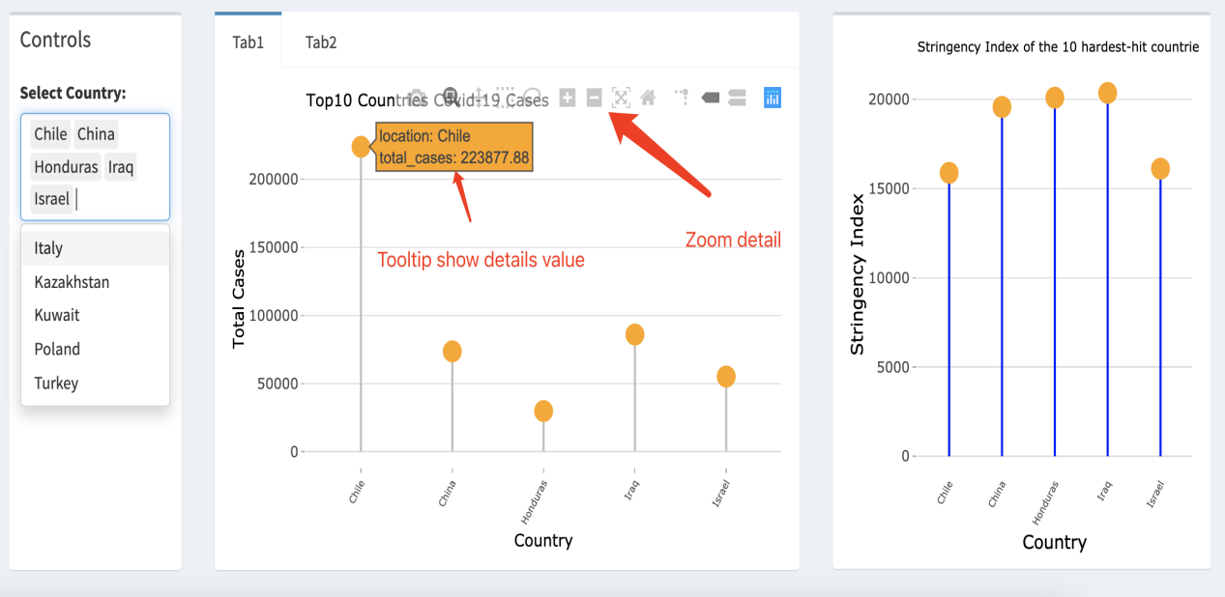

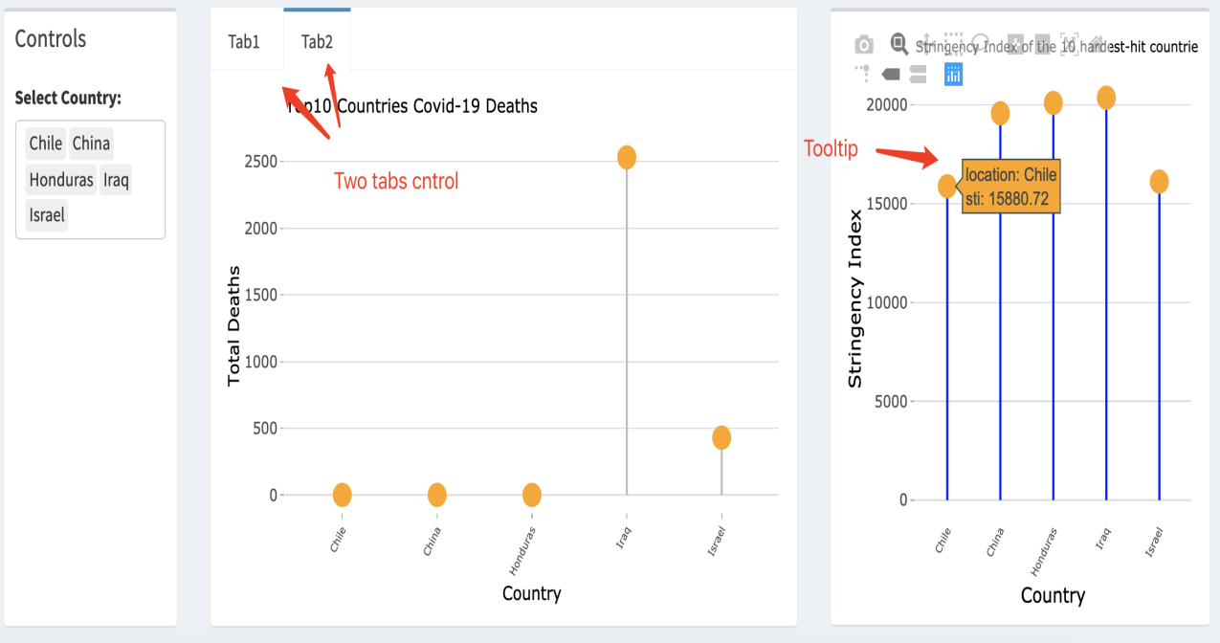

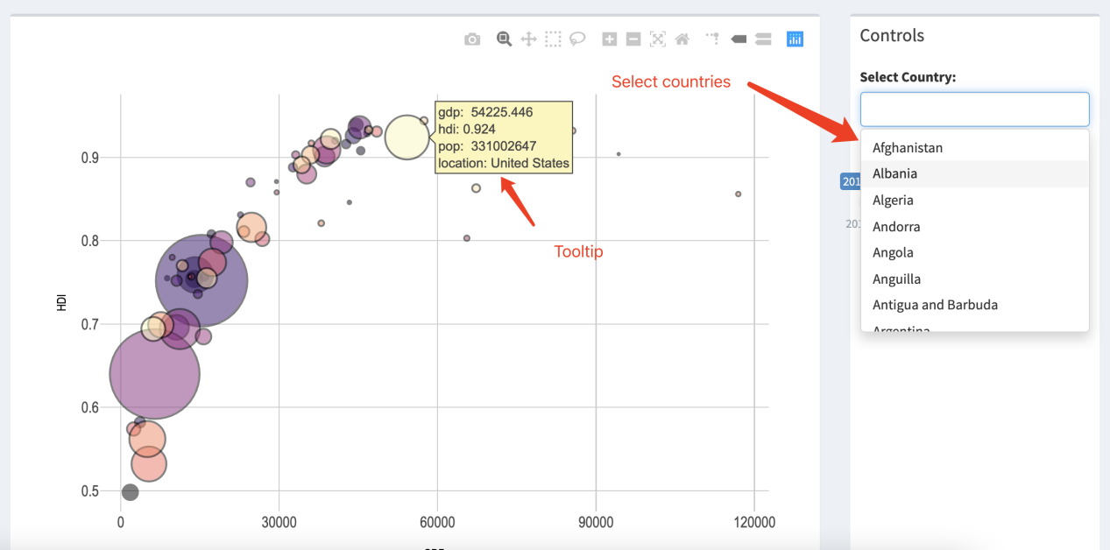

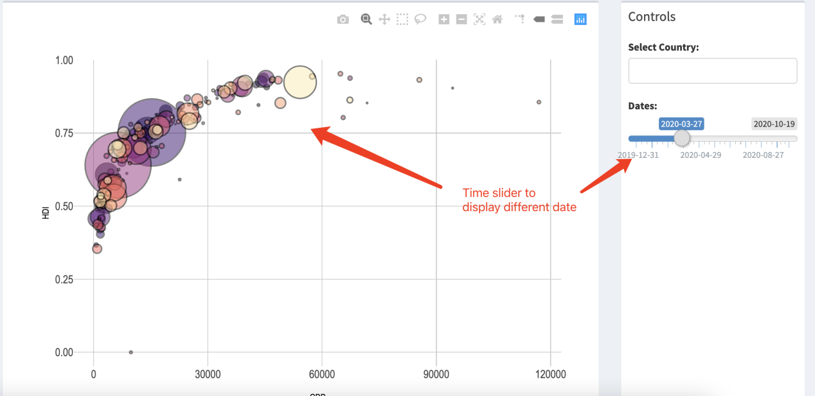

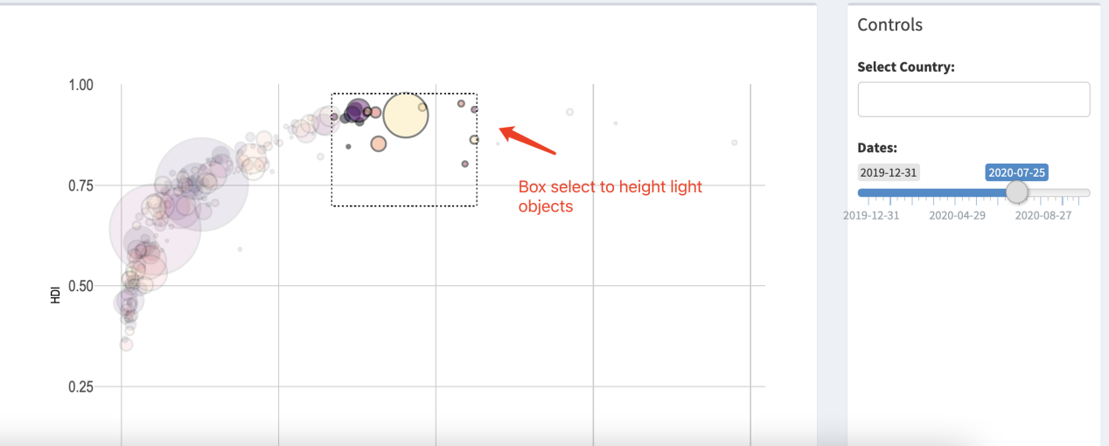

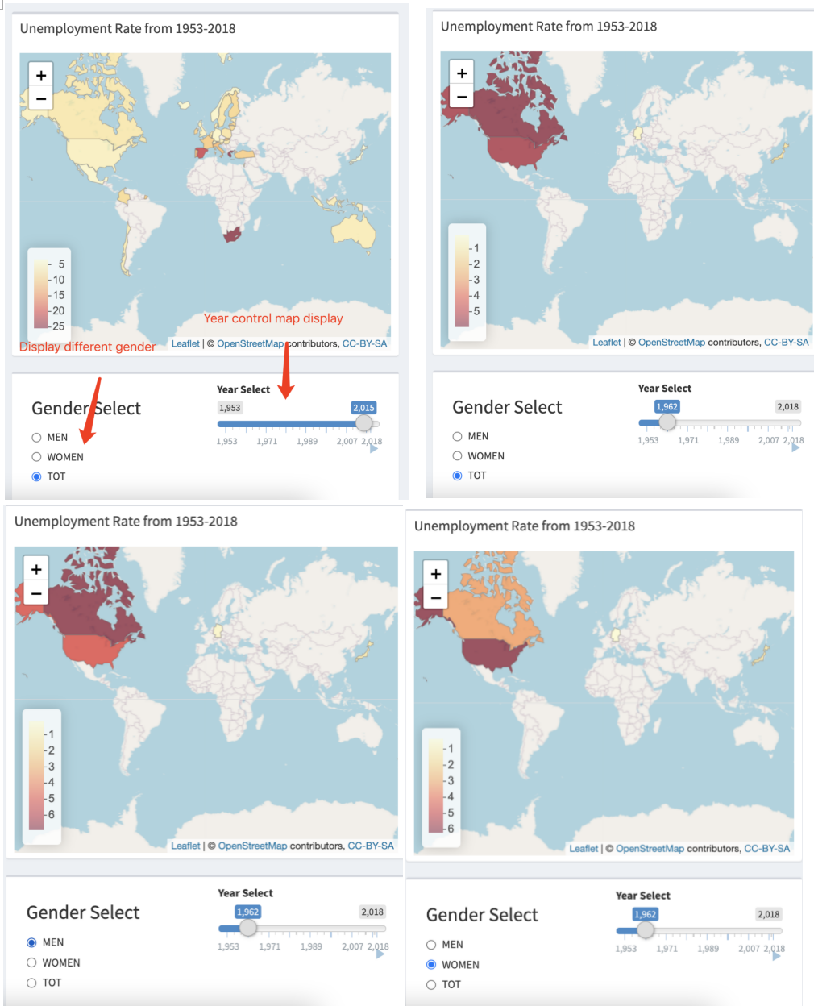

Map are implemented by leaflet, and there are two filters one represent the gender selection other is time series control. The map could zoom to display details information by + and - from the left top control panel.

# Difficulty

The entire project is built through R shiny, where the geographic information data has been identified and processed. The original data does not contain the geom-data of the country, and the shape data of each country needs to be obtained through a third-party package. This step is very difficult for data cleaning and wrangling.

And linked interactive is designed in the diagram, so that a drop-down box can control multiple diagrams at the same time.

Conclusion  
The world experienced a disaster in 2020, with the emergence of COVID-19 affecting the entire globe to varying degrees. Nearly 150 countries closed all schools and forced the cancellation of activities during the outbreak. The Human Development Index is the ultimate criterion for evaluating the development of a country. The higher human development index, the better the chances of citizens to survive the COVID-19 pandemic.

The Stringency Index is a number from 0 to 100 that reflects these indicators. A higher index score indicates a higher level of stringency. The value of STI can show the degree of control of a country, which also directly affects the total death and total case during COVID-19.

Appendix  
